Chapter 9, Solution 72.
j2 
j2 
j2 
-j9 
-j18 
b
a

R₁
R₂
R₃
Transform the delta connections to wye connections as shown below.

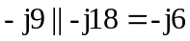,

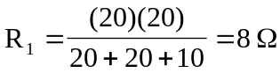, 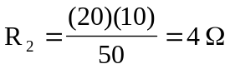, 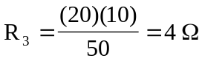

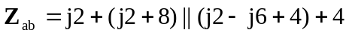
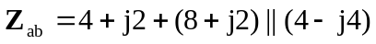
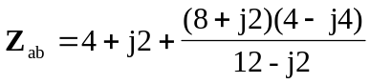
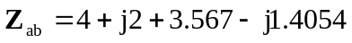
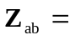 (7.567 + j0.5946) 

